Mid Trimester Crit

Project: Something Old Something New

Commission Brief: Three rings, one engagement ring and two wedding rings.

Personal Aim: Gain technical skills in a number of areas including stone setting and enameling. Learning about the history of marriage jewellery and contemporary art jewellery pertaining to the ritual.

Wedding Ring Research:
Records of rings symbolic of love and commitment akin to marriage date back to ancient Egypt. These rings started simply, made from woven natural fibers. The Romans were the first to use metal for wedding rings. These rings were still quite simple and largely made from base metals. In the middle ages the wedding ring began to bloom in its design complexity and material value. Many design styles came in and out of fashion across Europe over the centuries.

My design path has taken inspiration mainly from two kinds of rings. Gimmel rings are made of two or more interlinked bands with a unified design. These rings could displace complex carving and enameling on a miniature scale that is incredible for the technology available to their craftsmen. The second type of ring is the Posy ring. Posy rings are named such for bearing an inscription of a poem or phrase. Early examples of these rings bore elaborately carved script on the outside of the band. As fashions changed and weddings became more intimate affairs, the inscriptions shifted to the inside of the band and were more personalised to the couple.

Renaissance Gimmel Ring with Memento Mori
dated 1631
Metmuseum.org
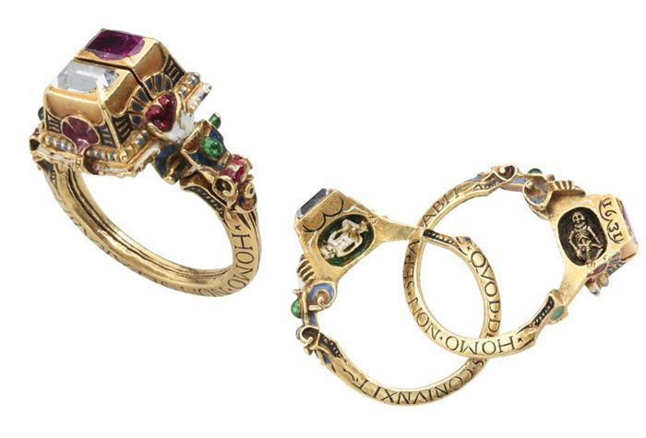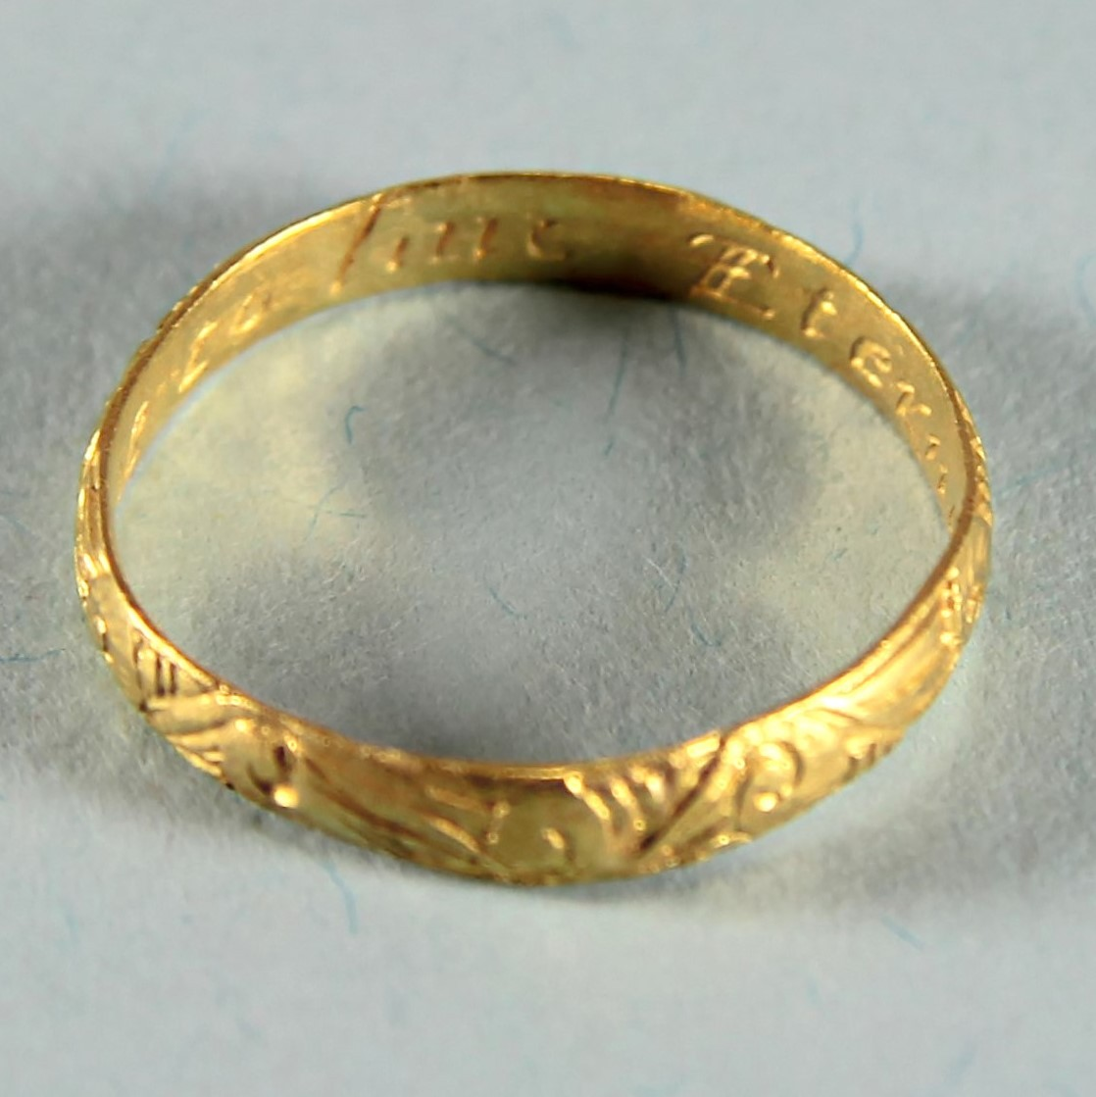
17th Century Gold Chased Posy Ring
Antique-silver.com
Wedding Ring Design:
I knew from the get go I wanted these rings to work harmoniously. At one point I was looking at puzzle rings. These are similar to gimmel rings but with the bands being separate, able to be worn by different individuals. Once I’d reviewed the client’s style references, I figured this would be outside of my abilities. So I have pivoted to a design that spills over between the two rings. All of the client’s example rings appear to be designed and printed digitally. I have some experience in this, having taken the digital jewellery course offered at QCA.
I have decided that I want to create two rings of similar design. One for Brenden, using 3D printing and one for myself using traditional techniques. The rings would feature a phrase on the inside of the band, engraved and enameled. I am still working through the design to be shared across the outside of these rings. I found the work of Marlon Obando Solano similar in profile to that I wanted to achieve.

Engagement Ring Research:
The client expressed interest in the engagement ring containing three elements. Firstl, an opal, the ring should feature either a bat or rat motif and wearability.
Upon researching opals, it was decided that a boulder opal would be chosen as they are found only in Queensland, the state both the bride and groom were raised in. Due to the non-uniform nature of opals and their cuts, the design process didn’t begin until the stone was chosen.
To approach the design, I looked at works in New Rings by Nicolas Estrada and found many unique designs. The client also provided examples of bat rings that appealed to her. The work of Julia Deville integrates stone settings with highly detailed sculptural forms but aren’t suitable for everyday wear. Nicolas Estrada’s work is similarly sculptural and is largely more wearable but lacks the stone set element. He also occasionally utilises enameling in his work.
I have continued a previous stream of personal research into silicone cast elements in my works. My latest batch of rings are experiments with the application of cast wax figures affixed to a band in various configurations. My mold includes bats of various sizes and a small rat with which I will work to design rings with stones and eventually settle on the final design for the engagement ring with the stone chosen for this purpose.
Examples of designs clients liked:
Alanna:
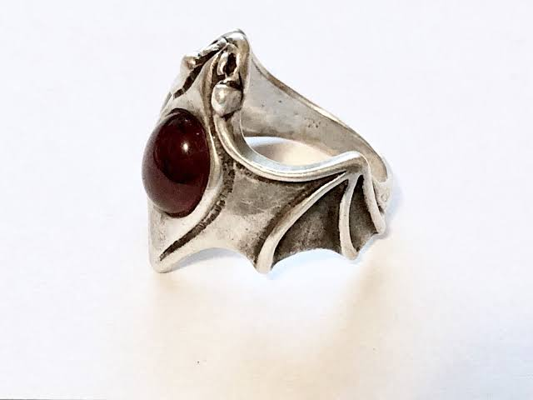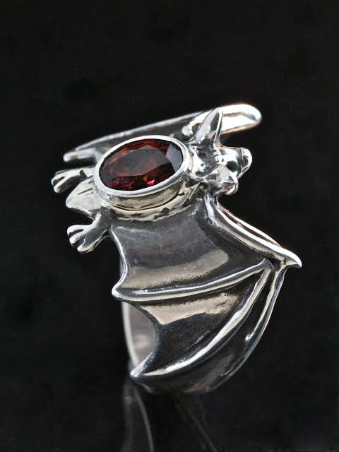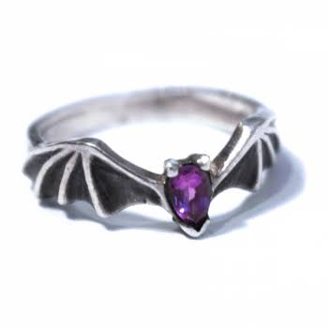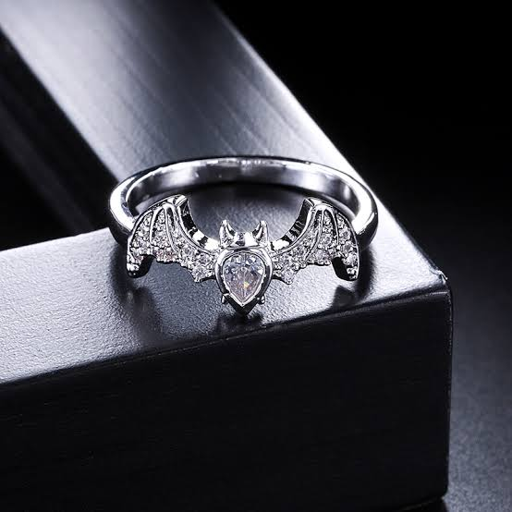
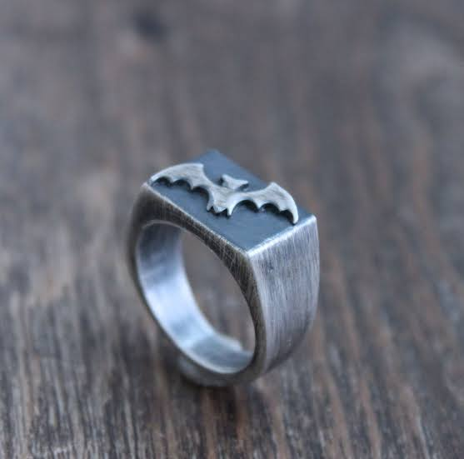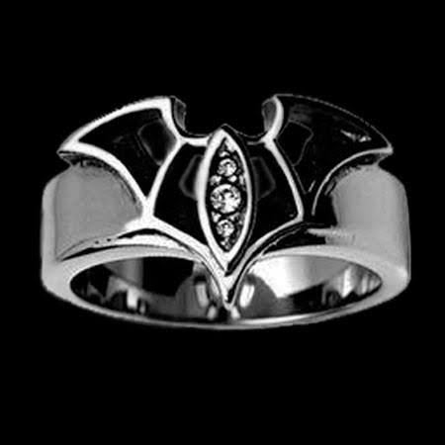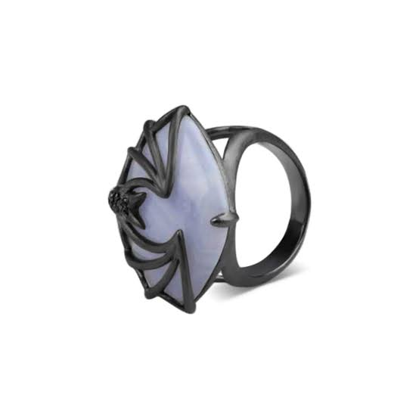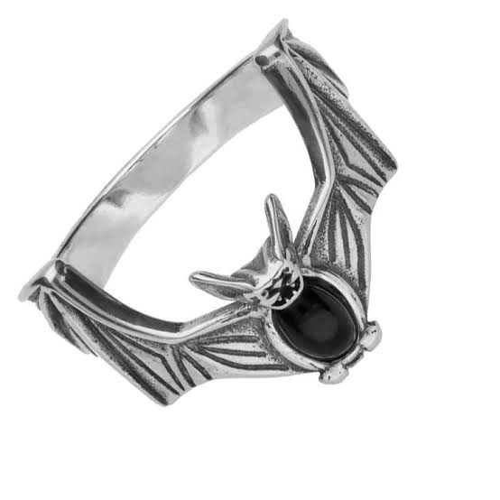
Brenden:
